Criterion B: Record of tasks

|  |  |  |  |  |  |
| --- | --- | --- | --- | --- | --- |
| Task number | Planned action | Planned outcome | Time estimated | Target completion date | Criterion |
| 1 | Choosing a topic and discuss idea with future client | Decided the problem and confirm with the willingness of Ms. Xx to collaborate as the client of my project | 2 days |  | A |
| 2 | Discuss idea with computer science teacher | Teacher approved the idea | 3 days |  | A |
| 3 | First interview with Mr. xx | Clear description of the problem | 2 days |  | A |
| 4 | Confirm my solution for the client’s problem with computer science teacher | Java chosen to be used as a solution for client | 2 days |  | A |
| 5 | Define criteria for success and finish with Criterion A | Criteria for success is defined and finished Criterion A | 2 days |  | A |
| 6 | Thinking on design of a product | Start developing basic design and create a flow chart | 1 week |  | B |
| 7 | Create a schedule for developing the software | Develop schedule in discussion with Mr. xx about the software | 1 week |  | B |
| 8 | Work on interface | Finish designing interface and agreed with Mr. xx | 1 week |  | B/C |
| 9 | Draw diagrams and flow charts to clarify the program working process | Finish diagrams and process description flow charts; finish Criterion B | 1 week |  | B |
| 10 | Think about a test to check whether the program works | Finished Detailed test plan | 1 week |  | B |
| 11 | Start writing actual code | Finished source code of Student class and SignIn class | 1 week |  | C |
| 12 | Finding more information about ActionListner and Scanner methods | Researched information from the internet | 5 days |  | C |
| 13 | Develop code and test every time to assure that everything works fine | Different classes and methods are added in whole program with that makes the code more readable; function testing should be made in whenever a change is made | 4 weeks |  | C |
| 14 | Finish writing criterion C | Finished extended writing together with the source code | 1 week |  | D |
| 15 | Test the final product solution | Show Mr. xx the final product | 2 days |  | D |
| 16 | Interview with Ms. xx | Get fedback from Ms. xx: testing results and suggestions about further developments | 1 day |  | A/ E |
| 17 | Think about how to further improve the program | Written ideas on how to improve program in future | 1 day |  | A/D/E |
| 18 | Record video to show programs functionality | Video is recorded successfully | 1 day |  | D |

Criterion B: Design

**Program basic (initial) structure:**

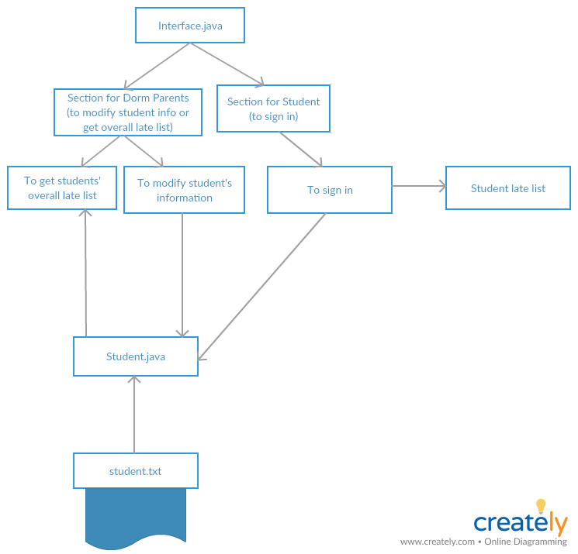

**Input data (Dorm parents)**

* Dorm parents can either choose to modify student information or get students’ overall late list
* When choose to modify student information, dorm parents have to first input the student’s ID number

|  |  |
| --- | --- |
| Ex: Normal data  Student ID number: 1111111 (must be seven-digit) | Ex: Abnormal data  Student ID number: 13ueydghbkasdkv |

Limitation: Dorm parents can only modify one student information at a time. Also, dorm parents cannot separate overall late list of a student, but every student’s overall late list.

* Student.txt must be typed in this specific way

|  |  |
| --- | --- |
| Ex: Normal data  Red(tie color) 1111111(ID number) Nerissa(name) 0(total late time) | Ex: Abnormal data  1111111 Red 1 Nerissa |

**Input data (Students action)**

* Data- students will input their ID number in order to sign in

|  |  |
| --- | --- |
| Ex: Normal data  Your student ID number: 1111111 | Ex: Abnormal data  Your student ID number: 21ssdkvosdljv |

When student input their ID number, their late status variable in their Student object will change to false, so that later they will not appear in the returning late list.

**Output data**

|  |  |
| --- | --- |
| Dorm parent’s section | Student Section |
| 1. a student late list in JTextArea will appear in a new window (can be printed) 2. student information can be modified as requested | 1. When the student sign in, they change their status in their information to false, so late they will not later identify as late |

**Flow Chart**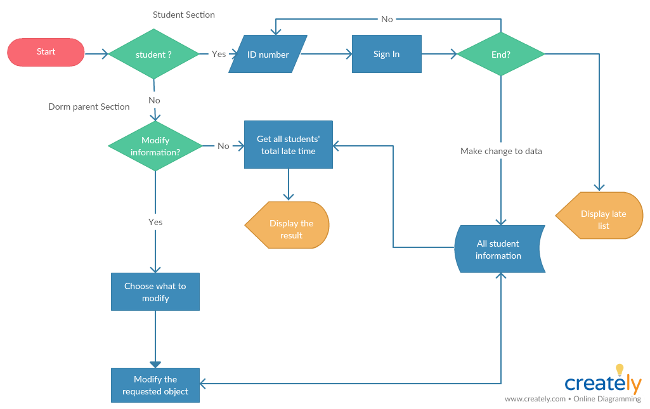

**Software Interface**

* Home window

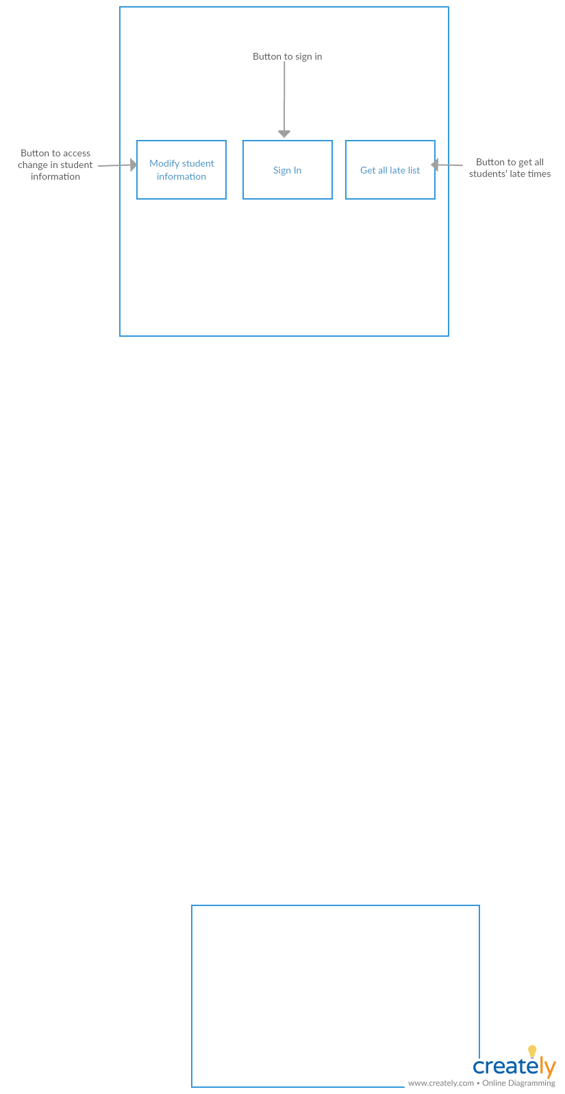

* Modify student information (for dorm parent’s section)

Dorm parents have to first clarify the student whose information they want to make change of.

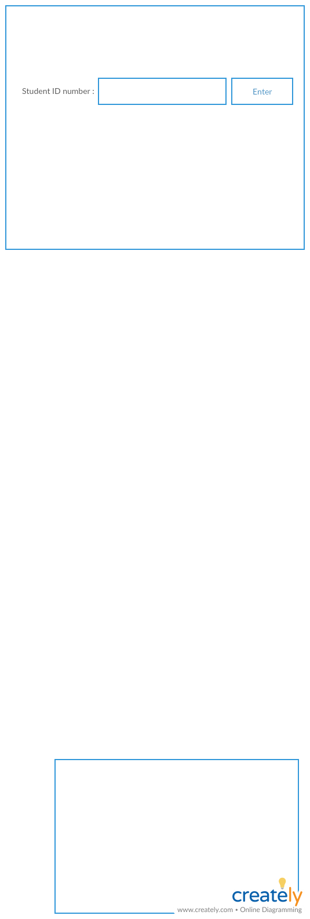

Exit

Then, the dorm parents can pick what they want to change among three options (requested by the client)

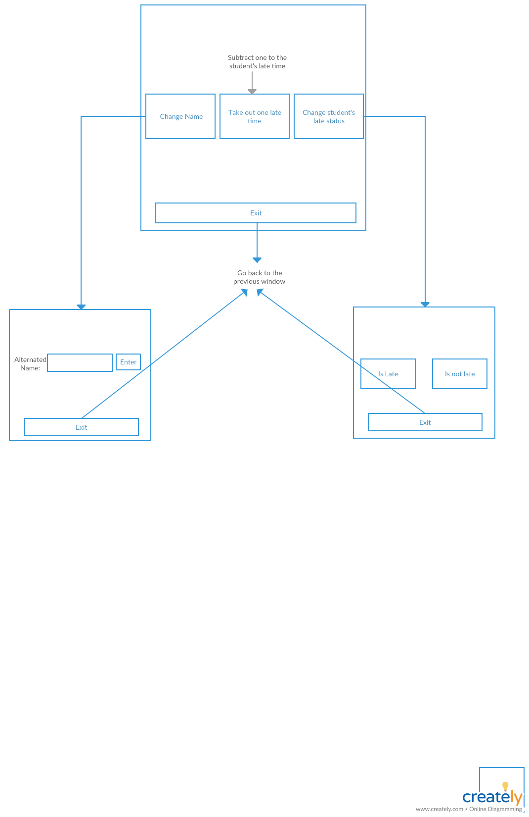

Get all late list (for dorm parent’s section)

* Result:

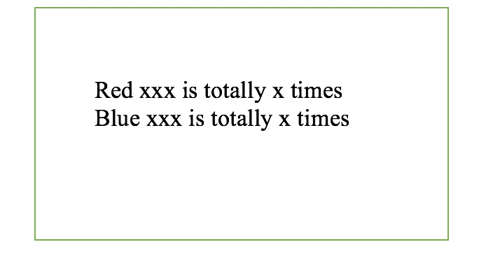

Sign in (for student’s section)

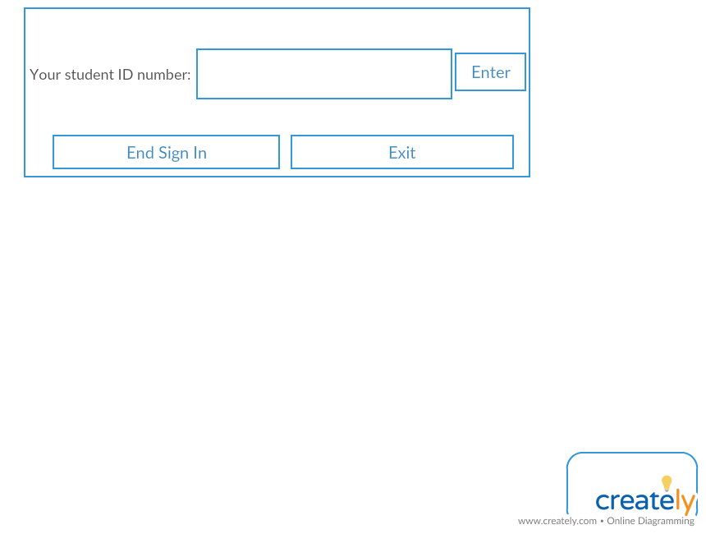

**Schedule for developing the program**

Program will be divided in three sections; Modify Student Information section for dorm parents to make change in student’s information; Get All Late List section for dorm parents to change the student’s late status; Sign In section for students to sign in for dinner

2 + 3 weeks will be enough to complete all sections:

|  |  |  |
| --- | --- | --- |
| Modify Student Information  (for dorm parent’s section) | Get All Late List  (for dorm parent’s section) | Sign In  (for student’s section) |
| * Create interface * Write a method that can find the student file by inputting the student’s ID number * Write code for exit button that allows user to go back to the previous window * Write code to prevent dorm parents from data entry errors | * Create interface * Write code that gets every student late time from the student file stored in Student object * Write code for exit button that allows user to go back to the previous window * Write a code that create a new window to display the data | * Create interface * Write code that will hold every student’s information from student.txt using Scanner and Student class * Write code for changing student late status and record the students who are late into an ArrayList * Write code for end sign button that create a new window that displays student who are absent list * Write code for exit button that allows user to go back to the previous window |
| Action Test | Action Test | Action Test |
| Test if the program runs correctly and appears on the main window | Test if the program runs correctly and appears on the main window | Test if the program runs correctly and appears on the main window |
| Check if the button works and leads to the right window | Check if the button works and leads to the right window | Check if the button works and leads to the right window |
| Check if the requested change is done and changed from the student.txt | Check if all the data is correct and compare it with the data in student.txt | Check if the students who sign in do not appear on the late list and appear those who supposed to do |
| Check if the program catches invalid student ID number | Check if the program has a proper size | Check if the program catches invalid student ID number |